🎯 Throughput Controller



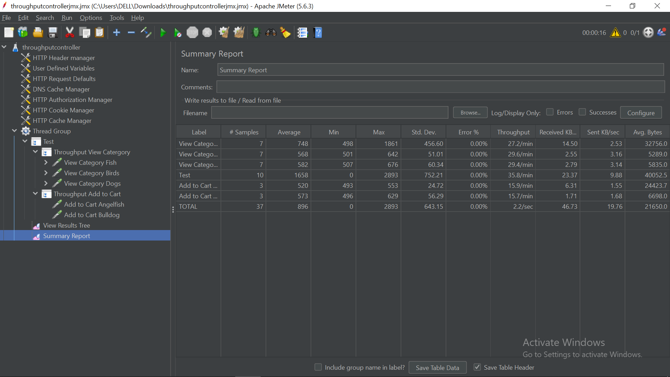

The **Throughput Controller** is a powerful **Logic Controller** that allows you to **control how frequently** its child elements are executed. It’s particularly useful for **simulating realistic user behavior** by mimicking the natural frequency of user actions within your application.

**🧠 Why Use the Throughput Controller?**

In real-world scenarios, not all user actions occur equally. For example:

* 🧭 80% of users might just browse.
* 🛒 15% might add products to the cart.
* 💳 Only 5% may complete a purchase.

The Throughput Controller allows you to **model this behavioral distribution** effectively in your test plan.

**⚙️ How It Works**

The Throughput Controller supports **two execution modes**:

**1. Percent Executions**

* Executes child elements **based on a percentage** of the total iterations.
* ✅ Best for modeling user behavior patterns.

**Example:**

* Thread Group: 100 total iterations.
* Throughput Controller: 20% (Percent Executions).
* ➤ Child samplers execute ~20 times.

**2. Total Executions**

* Executes child elements **a fixed number of times** during the test.
* ✅ Best for testing specific actions a limited number of times.

**Example:**

* Thread Group: 10 threads × 10 loops = 100 total iterations.
* Throughput Controller: Total Executions = 5.
* ➤ Child samplers will execute **exactly 5 times**, across all users.

**🔧 Key Configuration Options**

| **Setting** | **Description** |
| --- | --- |
| **Based On** | Choose between **Percent Executions** or **Total Executions**. |
| **Throughput** | Numeric value: Either the percentage or the total execution count. |
| **Per User** | - **Checked**: Throughput applies per user.  - **Unchecked (default)**: Throughput applies globally across all users. |

**🗂️ Example Structure**

java

CopyEdit

Test Plan

└── Thread Group

├── Throughput Controller (80%) - Browse Products

│ └── HTTP Request (Product Page)

│

├── Throughput Controller (15%) - Add to Cart

│ └── HTTP Request (Add to Cart)

│

└── Throughput Controller (5%) - Checkout

└── HTTP Request (Checkout)

**✅ When to Use the Throughput Controller**

* ✔️ **Model real-world user behavior**
* ✔️ **Control load distribution** across different functionalities
* ✔️ **Identify bottlenecks** by isolating low-frequency but critical transactions
* ✔️ **Design A/B test flows** with variable request paths

**⚠️ Throughput Controller vs. Constant Throughput Timer**

| **Feature** | **Throughput Controller** | **Constant Throughput Timer** |
| --- | --- | --- |
| Type | Logic Controller | Timer |
| Controls | **How often** samplers execute | **How fast** requests are sent (reqs/min) |
| Focus | **Flow control** | **Pacing/timing** |
| Use case | Distribute test logic | Maintain consistent request rate |